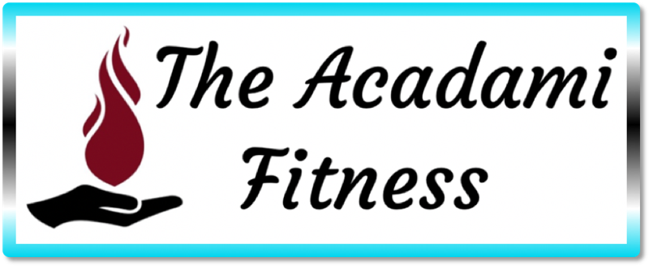

Example Meal Plan
1200-1300 Calories
High Protein
Moderate Carb
Low Fat

Note: these can be combined if you prefer to eat less frequently, bigger meals. As well, this is just an example, NOT what you must follow. At Acadami Fitness, we believe you should learn and grown and explore your food WHILE being health conscious. As well, the times are just for reference as it is optimal to have many smaller meals throughout the day, again, this is not a must, just an idea. We do not believe is prescribing strict, restrictive meal plans. These are just some ideas to get you going. Use your My Transphormation App, our Facebook Group, and your Coach for more recipes, ideas, and such.
– Love, Ami Davis, CEO, Lead Coach of Acadami Fitness

Training Day Example
(On non-training days, you will be able to have an additional meat and veggie meal)
Goals: 115g protein; 100g carbs; 40g fat

For those that don’t really like to eat first thing in the morning, do this:
6:00 AM Meal A)
An apple with 1 tbsp peanut butter; coffee if you want; ¾ scoop Level 1 either in the coffee or with water as a shake.
Macros: 22g protein; 32.6g carbs; 11.1g fat (total calories: 302)

OR – NOT BOTH;
for those that like to eat first thing, do this:
6:00 AM Meal B)
1 large, whole egg with ½ cup liquid egg whites; 2 slices: Killer Dave’s 21 Grain thin sliced toast with ½ tbsp Kerrygold butter
Macros: 25.3g protein; 25.3g carbs; 12.5g fat (total calories: 304)

12:00 PM
Salad (3 cups of any lettuce mix) with 2oz grilled chicken; ½ cup diced tomato, 1 cup sliced cucumber; 1 hard-boiled egg; 3 tbsp Hidden Valley Light Ranch Dressing
Macros: 27.6g protein; 17.7g carbs; 17.1g fat (total calories: 324)

3:00 PM
Level 1 Shake – ¾ scoop
Macros: 24g protein; 6g carbs; 3g fat (total calories: 150)
OR
1 cup Oikos Triple Zero yogurt with ½ cup blueberries + 4 strawberries (any berries)
Macros: 15.9g protein; 27.4g carbs; 0.4g fat (total calories: 168)

6:00 PM (after your resistance training session):
1 scoop Phormula 1 + ½ scoop Ignition (optional 1 scoop of 5g Creatine Monohydrate)
Macros: 20g protein; 26g carbs; 1g fat (total calories: 192)

7:00 PM
2oz grilled/baked salmon or chicken breast/ground turkey/turkey patty;
Mix of 1 cup cauliflower rice + ¼ cup brown rice & quinoa; 2 cup “free veggie” of choice (see below)
Macros:
2oz Salmon – 24.8g protein; 27.9g carbs; 5.9g fat (total calories: 272) OR
chicken 2oz – 30.5g protein; 27.9g carbs; 2.6g fat (total calories: 262) OR
turkey/patty (90% fat free) 2oz – 23.2g protein; 27.9g carbs; 6.8g fat (total calories: 262)

Level 1 powder: https://1stphorm.com/products/level-1/?a_aid=Ami‬‬‬‬‬‬‬‬‬
Level 1 bars: https://1stphorm.com/products/level-1-bar/?a_aid=Ami‬‬‬‬‬‬‬‬‬
Phormula 1 + Ignition (post workout stack): https://1stphorm.com/products/post-workout-stack/?a_aid=Ami‬‬‬‬‬‬‬‬‬

Shopping List:
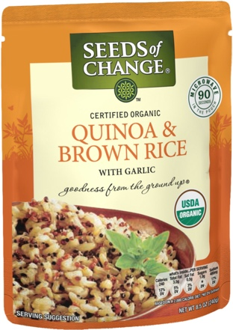
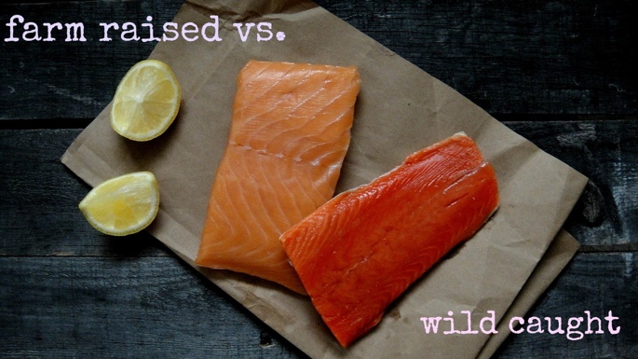
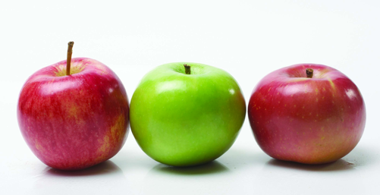
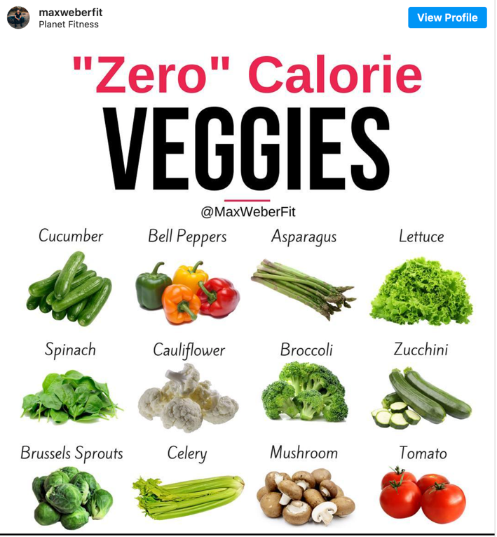
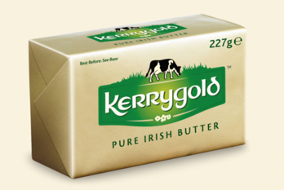
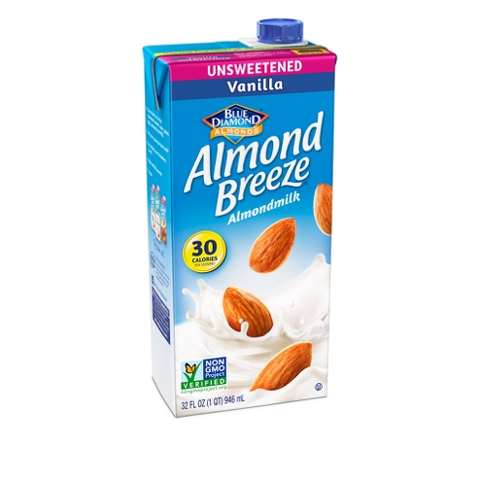
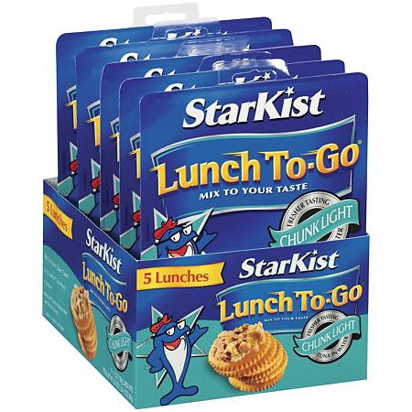
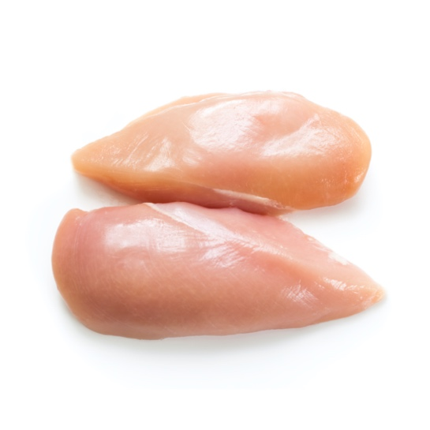
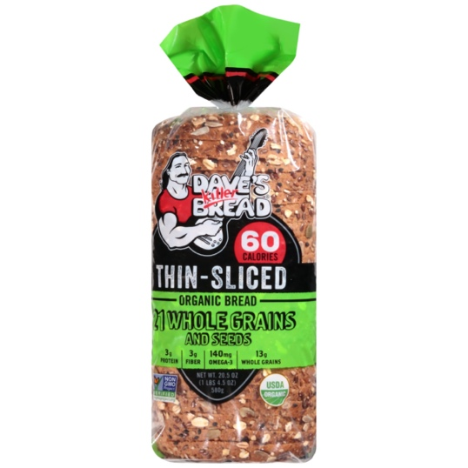
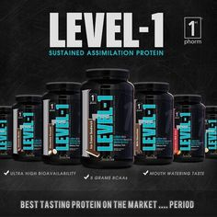
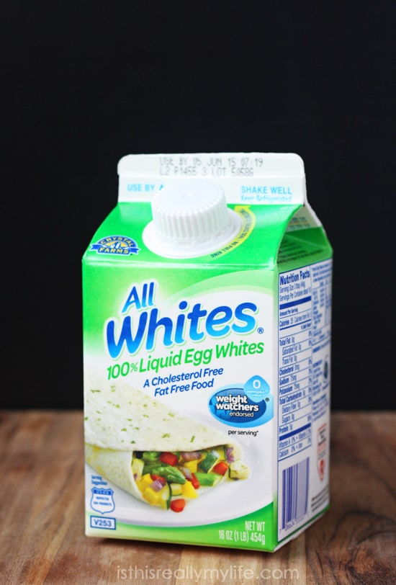

More Ideas:

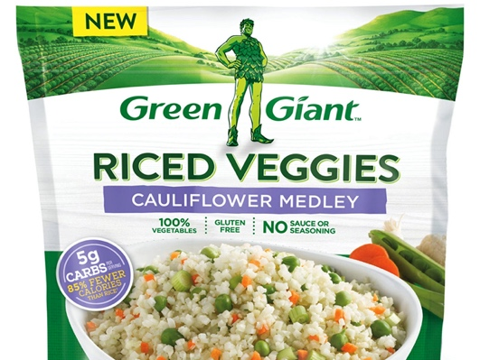
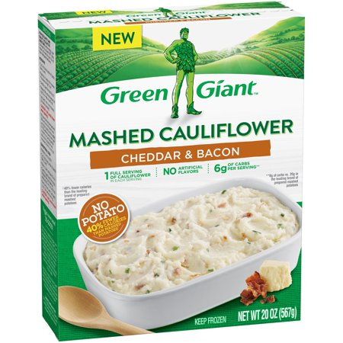
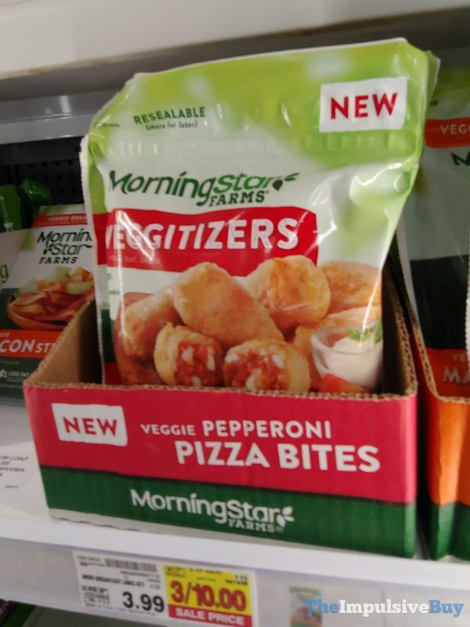

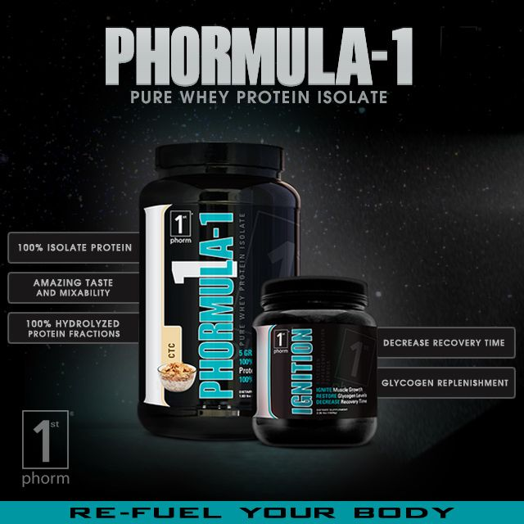

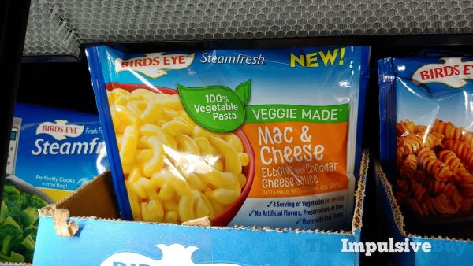

Example Meal Plan
1400-1500 Calories
High Protein
Moderate Carb
Low Fat

Note: these can be combined if you prefer to eat less frequently, bigger meals. As well, this is just an example, NOT what you must follow. At Acadami Fitness, we believe you should learn and grown and explore your food WHILE being health conscious. As well, the times are just for reference as it is optimal to have many smaller meals throughout the day, again, this is not a must, just an idea. We do not believe is prescribing strict, restrictive meal plans. These are just some ideas to get you going. Use your My Transphormation App, our Facebook Group, and your Coach for more recipes, ideas, and such.
Love, Ami Davis (CEO, Lead Coach of Acadami Fitness)

Training Day Example
(On non-training days, you will be able to have an addition meat and veggie meal)
Goals: 130g protein; 130g carbs; 40g fat

For those that don’t really like to eat first thing in the morning, do this:
6:00 AM Meal A)
An apple with 1 tbsp peanut butter; coffee if you want; 1 scoop Level 1 either in the coffee or almond-milk or with water as a shake.
Macros: 28g protein; 34.1g carbs; 11.8g fat (total calories: 340)

OR – NOT BOTH;

for those that like to eat first thing, do this:
6:00 AM Meal B)
1 large, whole egg with ½ cup liquid egg whites topped with 2 tbsp shredded cheese; 2 slices: Killer Dave’s 21 Grain thin sliced toast with ½ tbsp Kerrygold butter
Macros: 28.8g protein; 25.8g carbs; 17g fat (total calories: 359)

12:00 PM
Salad (3 cups of any lettuce mix) with 3oz grilled chicken; ½ cup diced tomato, 1 cup sliced cucumber; 1 hard-boiled egg; 3 tbsp Hidden Valley Light Ranch Dressing
Macros: 36.1g protein; 15.7g carbs; 14.3g fat (total calories: 324)

3:00 PM
Level 1 Shake (¾ scoop) + Banana
Macros: 24g protein; 6g carbs; 3g fat (total calories: 150)
OR
1 cup Oikos Triple Zero yogurt with ½ cup blueberries + 4 strawberries (any berries)
Macros: 15.9g protein; 27.4g carbs; 0.4g fat (total calories: 168)

6:00 PM (after your resistance training session):
1 scoop Phormula 1 + ½ scoop Ignition (optional 1 scoop of 5g Creatine Monohydrate)
Macros: 20g protein; 26g carbs; 1g fat (total calories: 192)

7:00 PM
3oz grilled/baked salmon or chicken breast/ground turkey/turkey patty;
Mix 1 cup cauliflower rice + ¾ cup brown rice & quinoa; 1 cup “free veggie” of choice (see below)
Macros:
3oz Salmon – 29.2g protein; 45.4g carbs; 9.8g fat (total calories: 387) OR
3oz chicken – 37.7g protein; 45.4g carbs; 4.8g fat (total calories: 372) OR
3oz turkey/patty (90% fat free) – 26.7g protein; 45.4g carbs; 11g fat (total calories: 372)

Level 1 powder: https://1stphorm.com/products/level-1/?a_aid=Ami‬‬‬‬
Level 1 bars: https://1stphorm.com/products/level-1-bar/?a_aid=Ami‬‬‬‬
Phormula 1 + Ignition (post workout stack): https://1stphorm.com/products/post-workout-stack/?a_aid=Ami‬‬‬‬

Shopping List:

More Ideas:

Example Meal Plan
1600-1700 Calories
High Protein
Moderate Carb
Low Fat

Note: these can be combined if you prefer to eat less frequently, bigger meals. As well, this is just an example, NOT what you must follow. At Acadami Fitness, we believe you should learn and grown and explore your food WHILE being health conscious. As well, the times are just for reference as it is optimal to have many smaller meals throughout the day, again, this is not a must, just an idea. We do not believe is prescribing strict, restrictive meal plans. These are just some ideas to get you going. Use your My Transphormation App, our Facebook Group, and your Coach for more recipes, ideas, and such.
– Love, Ami Davis, CEO, Lead Coach of Acadami Fitness

Training Day Example
(On non-training days, you will be able to have an addition meat and veggie meal)
Goal(s): 150g; 138g carbs; 50g fat;

For those that don’t really like to eat first thing in the morning, do this:
6:00 AM Meal A)
An apple with 2 tbsp peanut butter; coffee if you want; 1 scoop Level 1 either in the coffee or almond-milk or with water as a shake.
Macros: 29.7g protein; 35.6g carbs; 6.7g fat (total calories: 387)

OR – NOT BOTH;
for those that like to eat first thing, do this:
6:00 AM Meal B)
1 large, whole egg with ½ cup liquid egg whites topped with 2 tbsp shredded cheese; 2 slices: Killer Dave’s 21 Grain thin sliced toast with ½ tbsp Kerrygold butter
Macros: 31.5g protein; 37.1g carbs; 20.3g fat (total calories: 435)

12:00 PM
Salad (3 cups of any lettuce mix) with 3oz grilled chicken; ½ cup diced tomato, 1 cup sliced cucumber; 2 hard-boiled egg; 3 tbsp Hidden Valley Light Ranch Dressing
Macros: 46g protein; 18.5g carbs; 27g fat (total calories: 491)

3:00 PM Level 1 Shake
Macros: 24g protein; 6g carbs; 3g fat (total calories: 150)
OR
1 cup Oikos Triple Zero yogurt with ½ cup blueberries + 4 strawberries (any berries)
Macros: 15.9g protein; 27.4g carbs; 0.4g fat (total calories: 168)

6:00 PM (after your resistance training session):
1 scoop Phormula 1 + ½ scoop Ignition (optional 1 scoop of 5g Creatine Monohydrate)
Macros: 20g protein; 26g carbs; 1g fat (total calories: 192)

7:00 PM
3oz grilled/baked salmon or chicken breast/ground turkey/turkey patty; Mix 1 cup cauliflower rice + ½ cup brown rice & quinoa; 2 cups “free veggie” of choice (see below)
Macros:
3oz Salmon – 27.9g protein; 34.7g carbs; 9g fat (total calories: 332) OR
3oz Chicken – 36.4g protein; 34.7g carbs; 4g fat (total calories: 317) OR
3oz turkey/patty (90% fat free) – 25.4g protein; 34.7g carbs; 10.3g fat (total calories: 317)

Level 1 powder: https://1stphorm.com/products/level-1/?a_aid=Ami‬‬‬
Level 1 bars: https://1stphorm.com/products/level-1-bar/?a_aid=Ami‬‬‬
Phormula 1 + Ignition (post workout stack): https://1stphorm.com/products/post-workout-stack/?a_aid=Ami‬‬‬

Shopping List:

More Ideas:

Example Meal Plan
1900-2100 Calories
High Protein
Moderate Carb
Low Fat

Note: these can be combined if you prefer to eat less frequently, bigger meals. As well, this is just an example, NOT what you must follow. At Acadami Fitness, we believe you should learn and grown and explore your food WHILE being health conscious. As well, the times are just for reference as it is optimal to have many smaller meals throughout the day, again, this is not a must, just an idea. We do not believe is prescribing strict, restrictive meal plans. These are just some ideas to get you going. Use your My Transphormation App, our Facebook Group, and your Coach for more recipes, ideas, and such.
– Love, Ami Davis, CEO, Lead Coach of Acadami Fitness

Training Day Example
(On non-training days, you will be able to have an addition meat and veggie meal)
Goals: 180-200g protein; 165-180g carbs; 68-73g fat

For those that don’t really like to eat first thing in the morning, do this:
6:00 AM Meal A)
An apple with 2 tbsp peanut butter; coffee if you want; 1 scoop Level 1 either in the coffee or almond-milk or with water as a shake.
Macros: 31.5g protein; 37.1g carbs; 20.3g fat (total calories: 435)

OR – NOT BOTH;
for those that like to eat first thing, do this:
6:00 AM Meal B)
1 cup liquid egg whites topped with ½ avocado; 2 slices: Killer Dave’s 21 Grain thin sliced toast with ½ tbsp Kerrygold butter
Macros: 33.5g protein; 32.2g carbs; 18.9g fat (total calories: 415)

12:00 PM
Salad (3 cups of any lettuce mix) with 3oz grilled chicken; ½ cup diced tomato, 1 cup sliced cucumber; 2 hard-boiled egg; ½ avocado; 3 tbsp Hidden Valley Light Ranch Dressing
Macros: 44g protein; 32.2g carbs; 33.5g fat (total calories: 556)

3:00 PM
Level 1 Shake + 1 cup Oikos Triple Zero yogurt with ½ cup blueberries + 4 strawberries
Macros: 39.9g protein; 33.4g carbs; 3.4g fat (total calories: 318)

6:00 PM (after your resistance training session):
2 scoops Phormula 1 + 1 scoop Ignition (optional 1 scoop of 5g Creatine Monohydrate)
Macros: 40g protein; g carbs; 3g fat (total calories: 384)

7:00 PM
4oz grilled/baked salmon or chicken breast/ground turkey/turkey patty; Mix 1 cup cauliflower rice + ½ cup brown rice & quinoa; 2 cups “free veggie” of choice (see below)
Macros:
4oz Salmon – 33.7g protein; 34.7g carbs; 11.3g fat (total calories: 377) OR
4oz chicken – 45.1g protein; 34.7g carbs; 4.7g fat (total calories: 357) OR
4oz turkey/patty (90% fat free) – 30.4g protein; 34.7g carbs; 13g fat (total calories: 357)

Level 1 powder: https://1stphorm.com/products/level-1/?a_aid=Ami‬‬‬
Level 1 bars: https://1stphorm.com/products/level-1-bar/?a_aid=Ami‬‬‬
Phormula 1 + Ignition (post workout stack): https://1stphorm.com/products/post-workout-stack/?a_aid=Ami‬‬‬

Shopping List:

More Ideas:

